**DBT Assignment 1 : College Club Management**

**Name :** Mohul Y P

**SRN :** PES1UG22CS360

**a)Database preparation**

**Clubs Table: The central entity that stores information about different clubs**

* **ClubID (primary key)**
* **ClubName (required)**
* **ClubType (categorizes clubs, e.g., "Sports")**
* **EstablishmentYear (when the club was founded)**

**Members Table: Stores student/member information with a link to their club**

* **MemberID (primary key)**
* **FirstName, LastName (required)**
* **Email (required, must be unique)**
* **PhoneNumber**
* **DOB (date of birth)**
* **ClubID (foreign key to Clubs table)**

**Events Table: Tracks events organized by clubs**

* **EventID (primary key)**
* **EventName (required)**
* **EventDate, EventLocation**
* **EventDescription (TEXT type for longer descriptions)**
* **ClubID (foreign key to Clubs table)**

**Activities Table: Records specific activities conducted by clubs**

* **ActivityID (primary key)**
* **ActivityName (required)**
* **ActivityDescription**
* **ActivityDate**
* **ClubID (foreign key to Clubs table)**

**FacultyMembers Table: Stores information about faculty members associated with clubs**

* **FacultyID (primary key)**
* **FirstName, LastName (required)**
* **Email (required, must be unique)**
* **PhoneNumber**
* **ClubID (foreign key to Clubs table)**

**Relational Schema:**

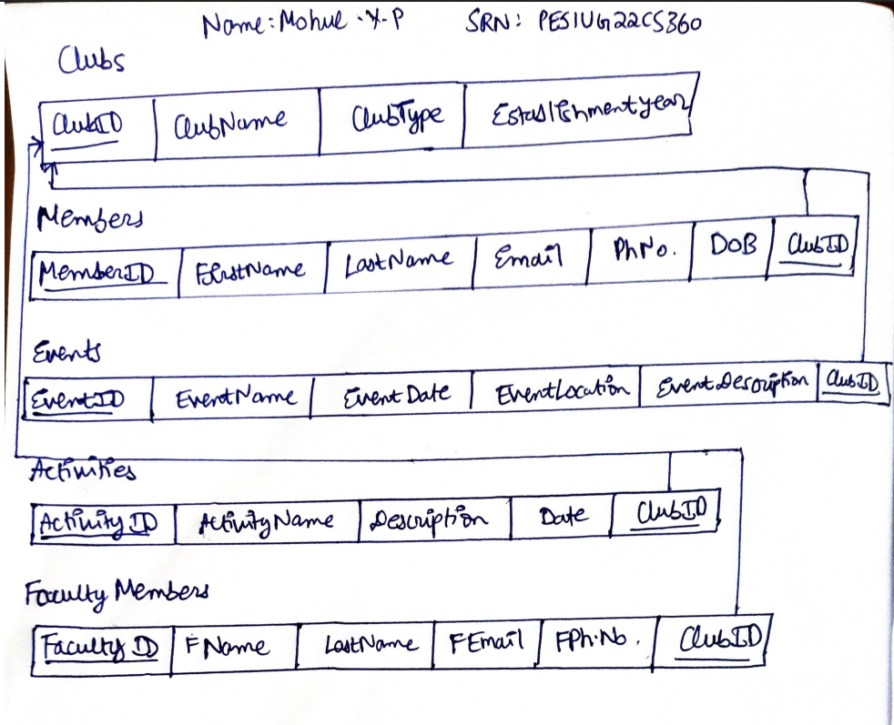

**To fill the tables with 10,000 rows, I used a python script which will be in the folder along with this submission.**

b)**select and count queries on “clubs” table**

**SELECT * FROM Clubs;**

**SELECT COUNT(*) FROM Clubs;**

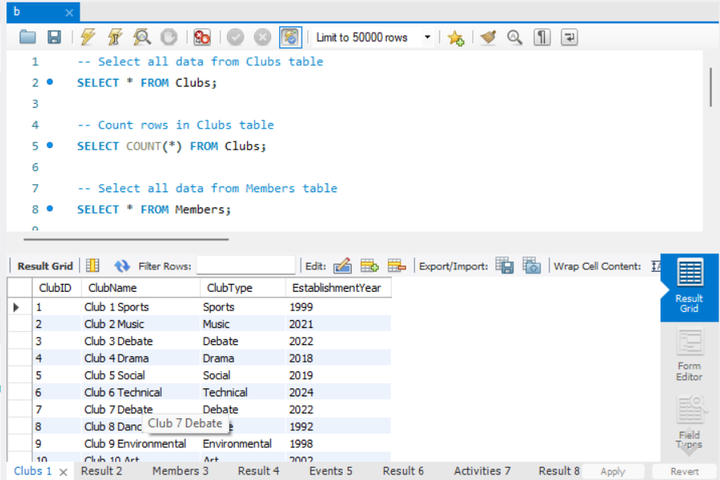

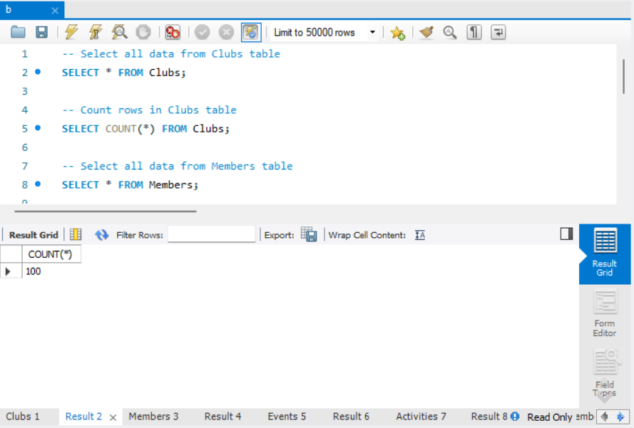

**select and count queries on “member” table**

**SELECT * FROM Members;**

**SELECT COUNT(*) FROM Members;**

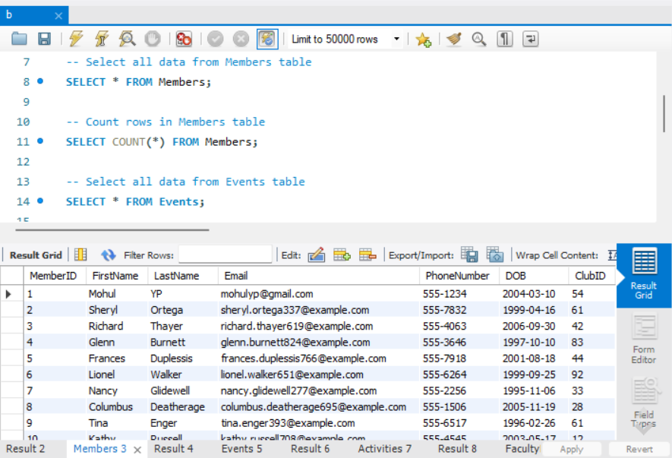

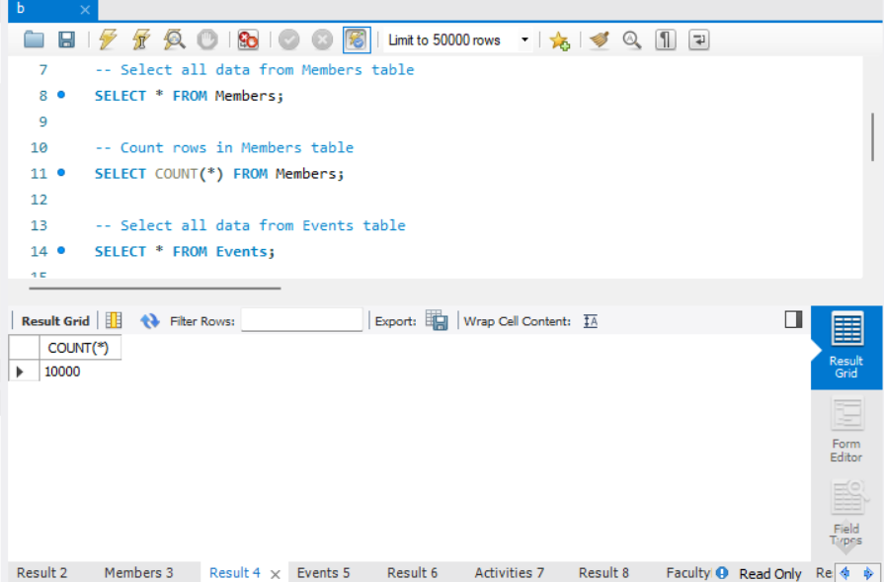

**select and count queries on “events” table**

**SELECT * FROM Events;**

**SELECT COUNT(*) FROM Events;**

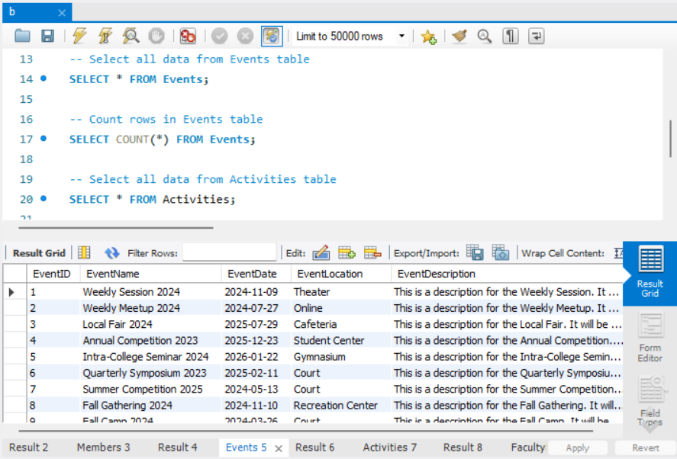

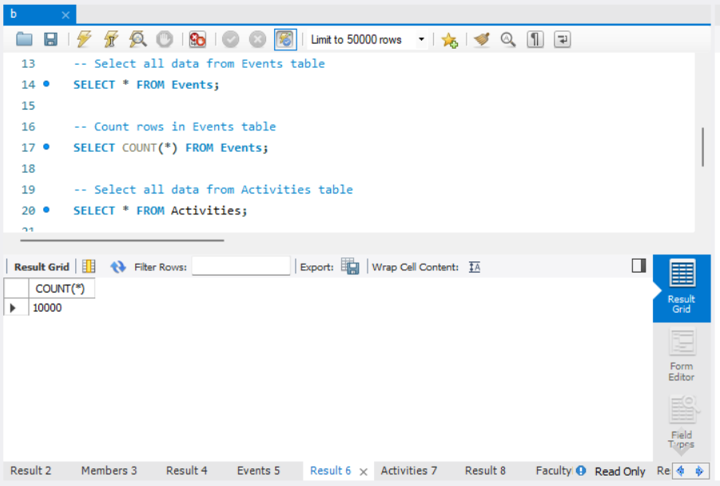

**select and count queries on “activities” table**

**SELECT * FROM Activities;**

**SELECT COUNT(*) FROM Activities;**

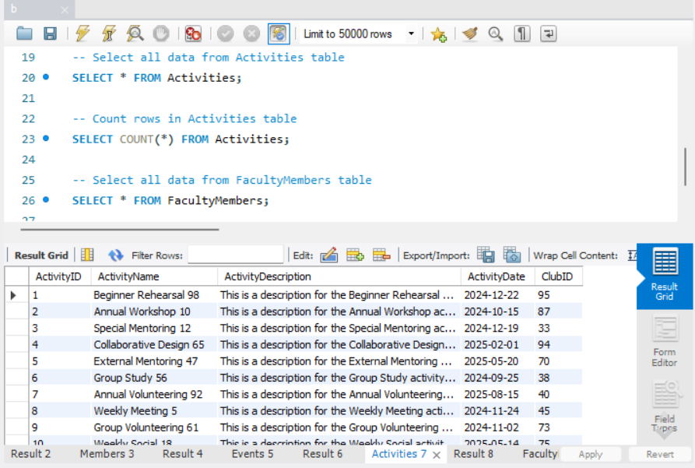

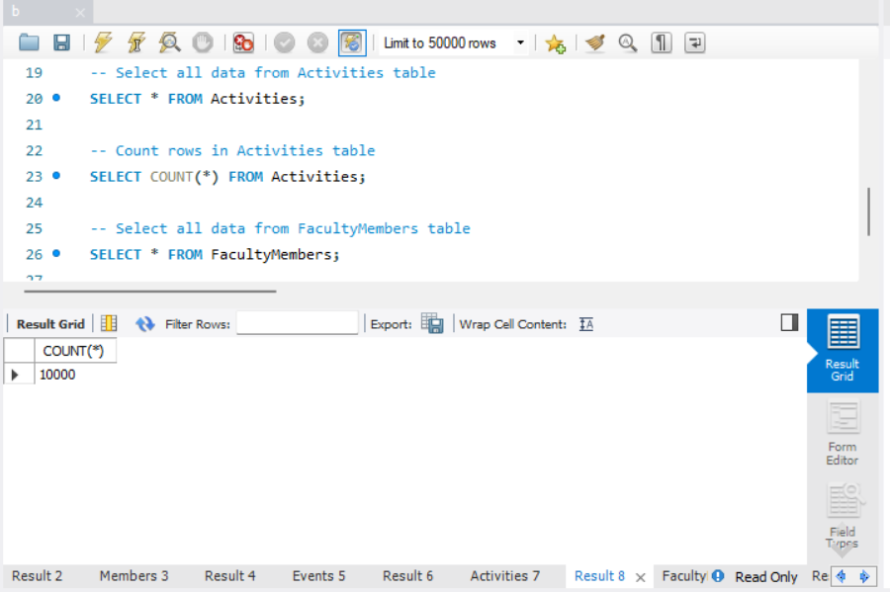

**select and count queries on “faculty members” table**

**SELECT * FROM FacultyMembers;**

**SELECT COUNT(*) FROM FacultyMembers;**

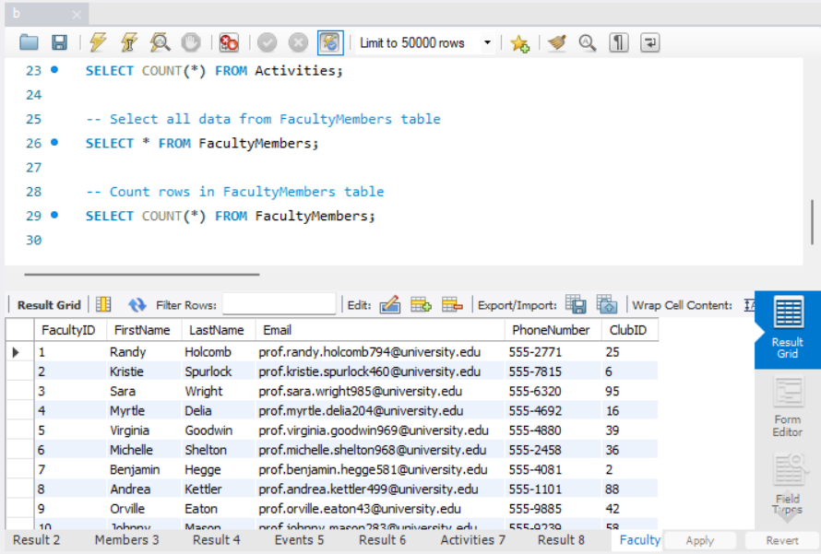

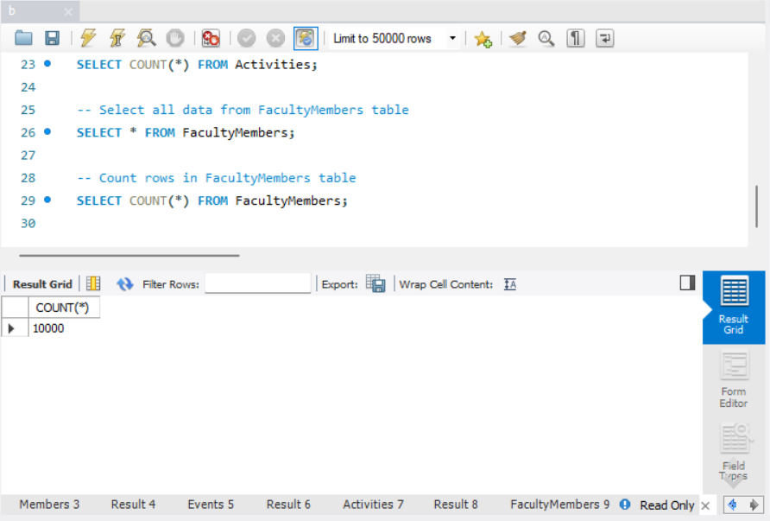

**INDEX SCAN**

**1)** **SELECT FirstName, LastName, Email**

**FROM Members**

**WHERE ClubID = 1**

**AND DOB > '1990-01-01'**

**AND Email LIKE '%@example.com';**

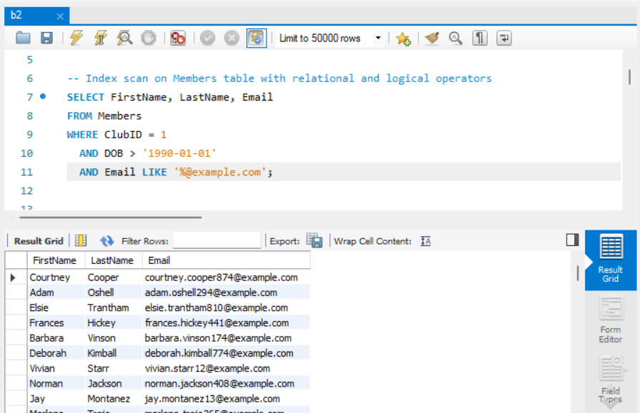

**ClubID is automatically an index as it is a primary key**

**TABLE SCAN**

1. **– table scan on members to find members born after 1990 ordered by first name who are not in sports clubs established after 2000**

**SELECT \***

**FROM Members m**

**WHERE m.ClubID NOT IN (**

**SELECT c.ClubID**

**FROM Clubs c**

**WHERE c.ClubType = 'Sports' AND c.EstablishmentYear > 2000**

**)**

**AND m.DOB > '1990-01-01'**

**ORDER BY m.FirstName;**

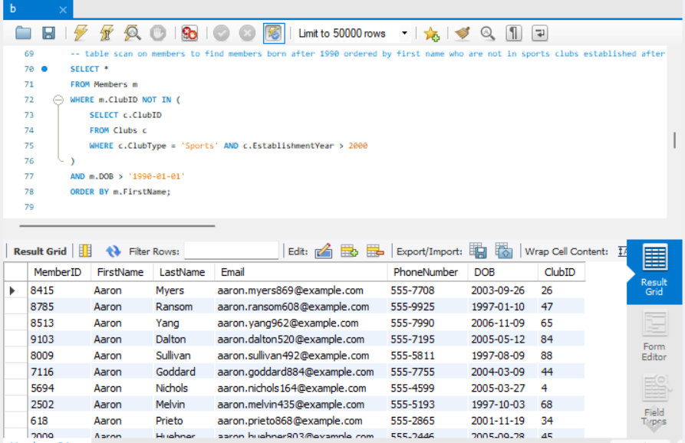

**2) --table scan on join of activities and members table.**

**SELECT a.ActivityName, COUNT(m.MemberID) AS MemberCount**

**FROM Activities a**

**LEFT JOIN Members m ON a.ClubID = m.ClubID**

**GROUP BY a.ActivityName**

**HAVING COUNT(m.MemberID) > 3**

**ORDER BY MemberCount DESC;**

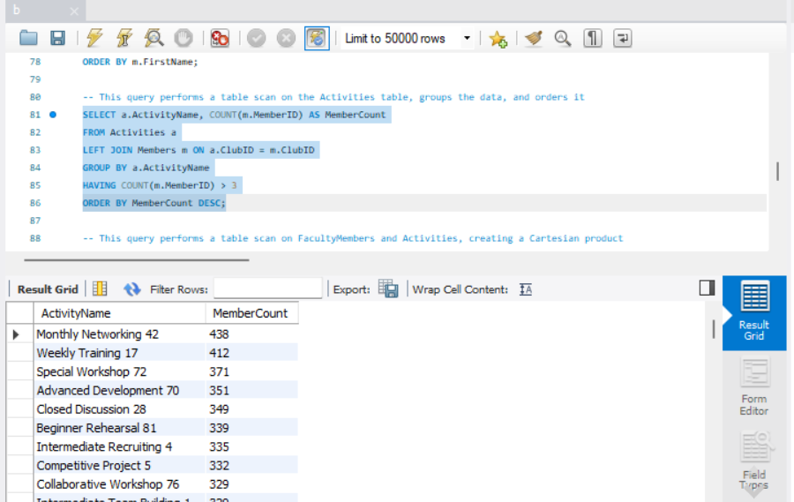

**3)** **-- This query performs a table scan on FacultyMembers and Activities, creating a Cartesian product**

**SELECT f.FirstName, f.LastName, a.ActivityName**

**FROM FacultyMembers f**

**CROSS JOIN Activities a;**

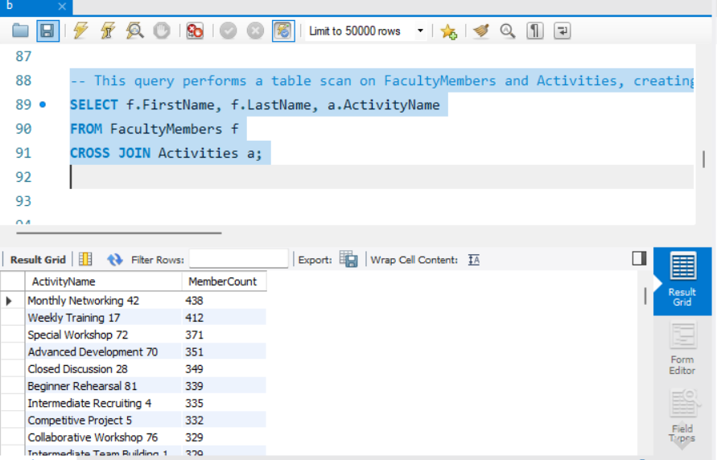

**queries with multi-table joins involving 3 tables; including both "SELECT *" and**

**conditional "SELECT" queries with a subset of columns.**

**1)** **SELECT c.ClubName, COUNT(m.MemberID) AS MemberCount**

**FROM Members m**

**INNER JOIN Clubs c ON m.ClubID = c.ClubID**

**INNER JOIN Events e ON c.ClubID = e.ClubID**

**WHERE e.EventDate > '2024-01-01' AND c.ClubType = 'Sports'**

**GROUP BY c.ClubName**

**HAVING COUNT(m.MemberID) > 3**

**ORDER BY MemberCount DESC;**

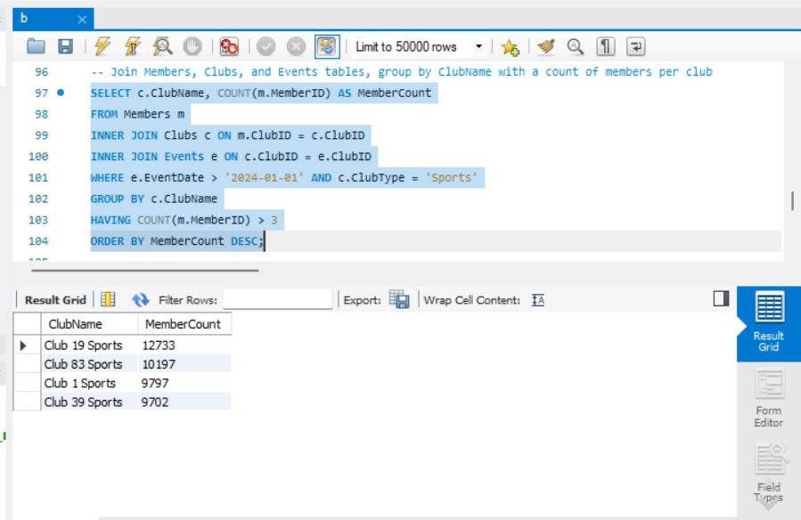

**2)**

**SELECT \***

**FROM Members m**

**INNER JOIN Clubs c ON m.ClubID = c.ClubID**

**INNER JOIN Events e ON c.ClubID = e.ClubID**

**WHERE e.EventDate IN (**

**SELECT e2.EventDate**

**FROM Events e2**

**WHERE e2.EventLocation = 'Hall A' AND e2.EventDate > '2025-01-01'**

**)**

**ORDER BY e.EventDate;**

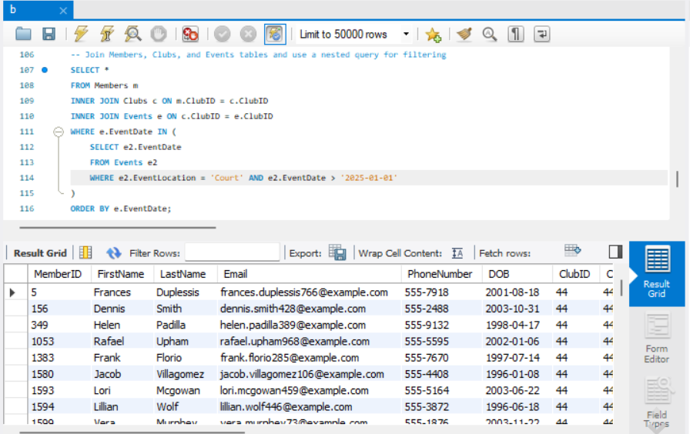

**3)** **CREATE VIEW ClubMembers AS**

**SELECT c.ClubName, m.FirstName, m.LastName, m.Email**

**FROM Clubs c**

**INNER JOIN Members m ON c.ClubID = m.ClubID;**

**-- Query using the view to select a subset of columns with filtering**

**SELECT ClubName, FirstName, LastName**

**FROM ClubMembers**

**WHERE ClubName = 'Club 54 Dance' AND LastName = 'YP';**

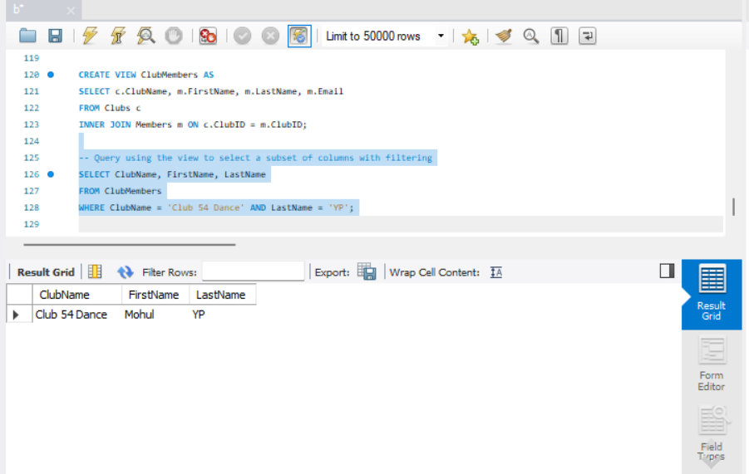

**EXPLAIN ANALYZE on each of the queries mentioned above :**

**INDEX SCAN**

**1)** **EXPLAIN ANALYZE**

**SELECT FirstName, LastName, Email**

**FROM Members**

**WHERE ClubID = 1**

**AND DOB > '1990-01-01'**

**AND Email LIKE '%@example.com';**

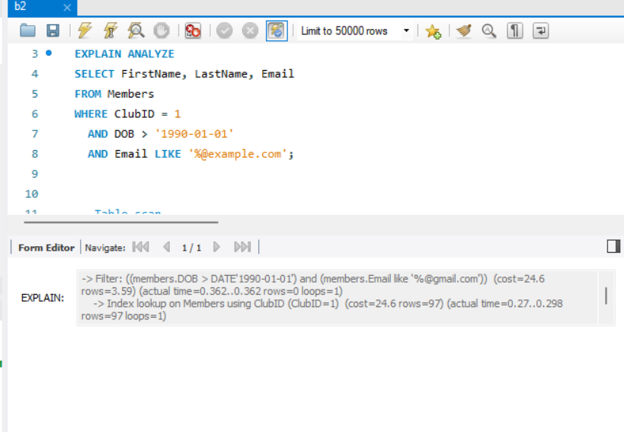

**TABLE SCAN**

**1)**

**EXPLAIN ANALYZE**

**SELECT \***

**FROM Members m**

**WHERE m.ClubID NOT IN (**

**SELECT c.ClubID**

**FROM Clubs c**

**WHERE c.ClubType = 'Sports' AND c.EstablishmentYear > 2000**

**)**

**AND m.DOB > '1990-01-01'**

**ORDER BY m.FirstName;**

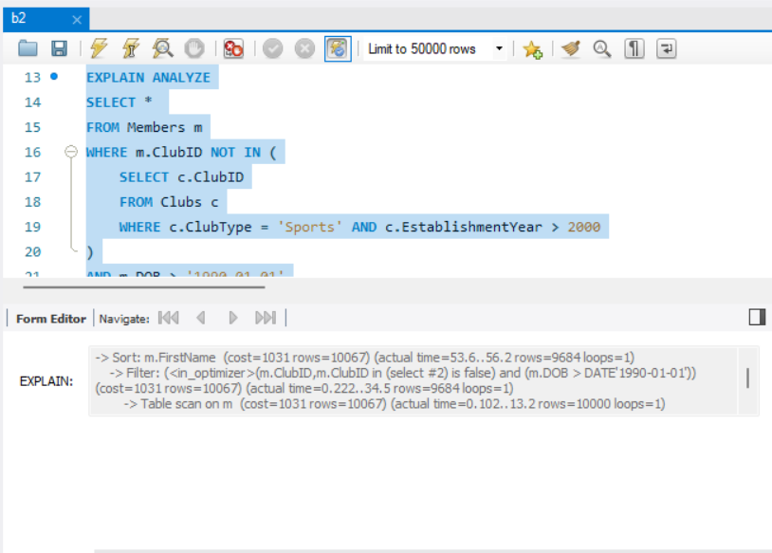

**2)**

**EXPLAIN ANALYZE**

**SELECT a.ActivityName, COUNT(m.MemberID) AS MemberCount**

**FROM Activities a**

**LEFT JOIN Members m ON a.ClubID = m.ClubID**

**GROUP BY a.ActivityName**

**HAVING COUNT(m.MemberID) > 3**

**ORDER BY MemberCount DESC;**

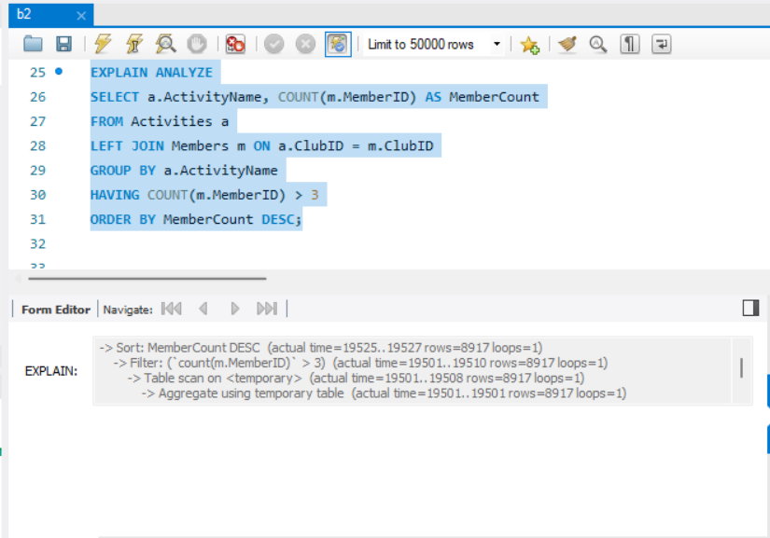

**3)**

**EXPLAIN ANALYZE**

**SELECT f.FirstName, f.LastName, a.ActivityName**

**FROM FacultyMembers f**

**CROSS JOIN Activities a;**

**Since we are doing a cross join(approximately 100000000 rows), the execution time is a lot and exceeds the limit set by the SQL server. Therefore, EXPLAIN ANALYZE could not be run**

**queries with multi-table joins involving 3 tables; including both "SELECT *" and**

**conditional "SELECT" queries with a subset of columns.**

**1)**

**EXPLAIN ANALYZE**

**SELECT c.ClubName, COUNT(m.MemberID) AS MemberCount**

**FROM Members m**

**INNER JOIN Clubs c ON m.ClubID = c.ClubID**

**INNER JOIN Events e ON c.ClubID = e.ClubID**

**WHERE e.EventDate > '2024-01-01' AND c.ClubType = 'Sports'**

**GROUP BY c.ClubName**

**HAVING COUNT(m.MemberID) > 3**

**ORDER BY MemberCount DESC;**

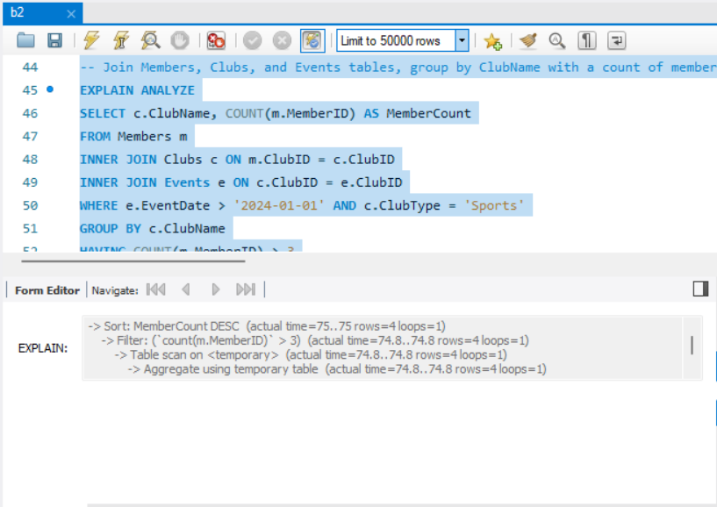

**2)**

**EXPLAIN ANALYZE**

**SELECT \***

**FROM Members m**

**INNER JOIN Clubs c ON m.ClubID = c.ClubID**

**INNER JOIN Events e ON c.ClubID = e.ClubID**

**WHERE e.EventDate IN (**

**SELECT e2.EventDate**

**FROM Events e2**

**WHERE e2.EventLocation = 'Court' AND e2.EventDate > '2025-01-01'**

**)**

**ORDER BY e.EventDate;**

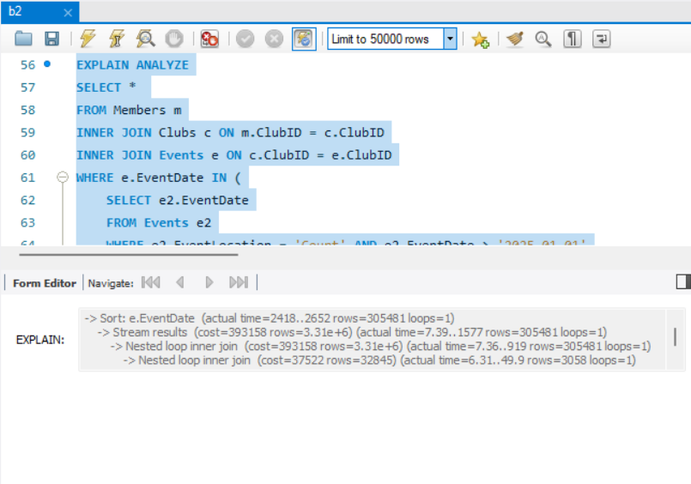

**3)**

**CREATE VIEW ClubMembers AS**

**SELECT c.ClubName, m.FirstName, m.LastName, m.Email**

**FROM Clubs c**

**INNER JOIN Members m ON c.ClubID = m.ClubID;**

**EXPLAIN ANALYZE**

**-- Query using the view to select a subset of columns with filtering**

**SELECT ClubName, FirstName, LastName**

**FROM ClubMembers**

**WHERE ClubName = 'Club 54 Dance' AND LastName = 'YP';**

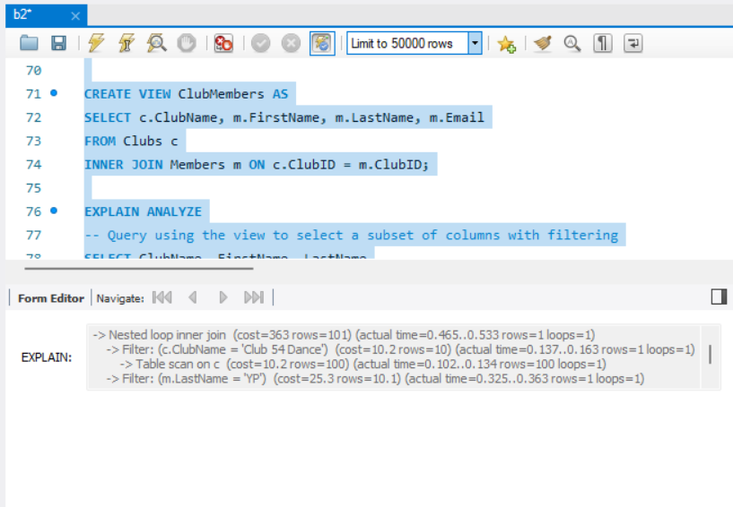

**c)**

**Indexes made to improve performance :**

**CREATE INDEX idx_members_dob_firstname ON Members(DOB, FirstName);**

**CREATE INDEX idx_clubs_clubtype_establishmentyear ON Clubs(ClubType, EstablishmentYear);**

**CREATE INDEX idx_clubs_clubname ON Clubs(ClubName);**

**CREATE INDEX idx_events_eventdate ON Events(EventDate);**

**1)analyzing below query :**

**SELECT \***

**FROM Members m**

**WHERE m.ClubID NOT IN (**

**SELECT c.ClubID**

**FROM Clubs c**

**WHERE c.ClubType = 'Sports' AND c.EstablishmentYear > 2000**

**)**

**AND m.DOB > '1990-01-01'**

**ORDER BY m.FirstName;**

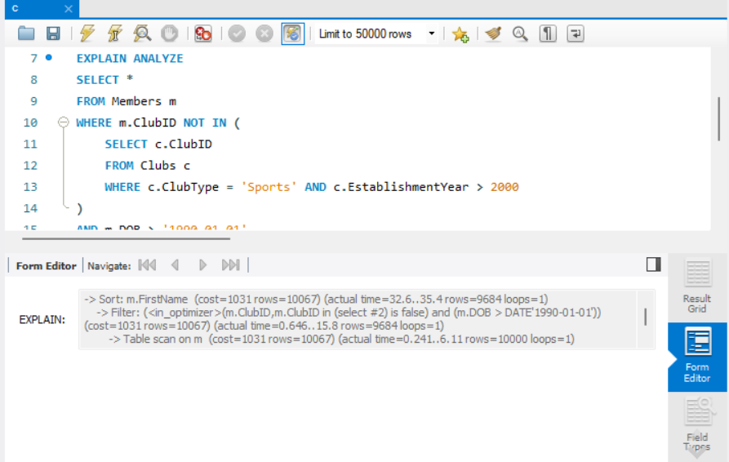

**Old query with indexes :**



**As we can see the execution time has reduced from 53.6 sec to 32.6 sec**

**2)analyzing below query :**

**SELECT c.ClubName, COUNT(m.MemberID) AS MemberCount**

**FROM Members m**

**INNER JOIN Clubs c ON m.ClubID = c.ClubID**

**INNER JOIN Events e ON c.ClubID = e.ClubID**

**WHERE e.EventDate > '2024-01-01' AND c.ClubType = 'Sports'**

**GROUP BY c.ClubName**

**HAVING COUNT(m.MemberID) > 3**

**ORDER BY MemberCount DESC;**

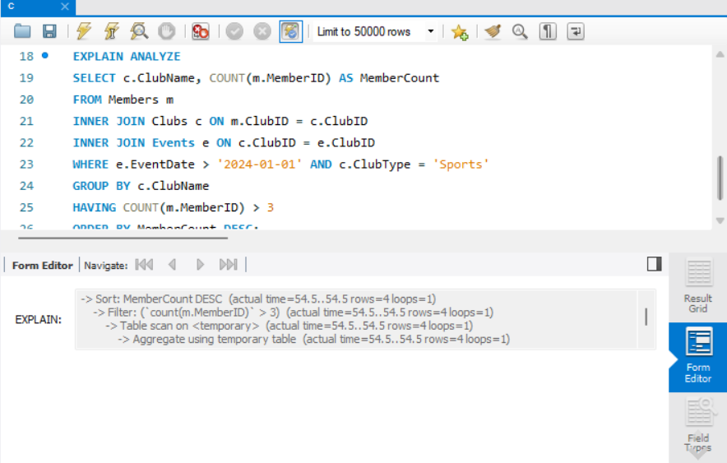

**Old query without indexes:**



**As we can see, execution time has reduced from 75 sec to 54.5 sec**

**d) The multi join query to optimize :**

**1)**

**SELECT c.ClubName, COUNT(m.MemberID) AS MemberCount**

**FROM Members m**

**INNER JOIN Clubs c ON m.ClubID = c.ClubID**

**INNER JOIN Events e ON c.ClubID = e.ClubID**

**WHERE e.EventDate > '2024-01-01' AND c.ClubType = 'Sports'**

**GROUP BY c.ClubName**

**HAVING COUNT(m.MemberID) > 3**

**ORDER BY MemberCount DESC;**

**Running EXPLAIN ANALYZE on the above query :**

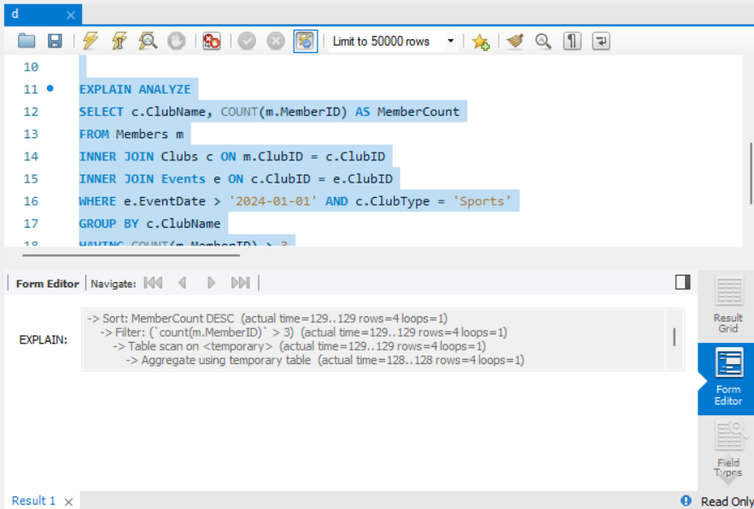

**Join order variation 1 : Start with clubs**

**SELECT c.ClubName, COUNT(m.MemberID) AS MemberCount**

**FROM Clubs c**

**INNER JOIN Events e ON c.ClubID = e.ClubID**

**INNER JOIN Members m ON c.ClubID = m.ClubID**

**WHERE e.EventDate > '2024-01-01' AND c.ClubType = 'Sports'**

**GROUP BY c.ClubName**

**HAVING COUNT(m.MemberID) > 3**

**ORDER BY MemberCount DESC;**

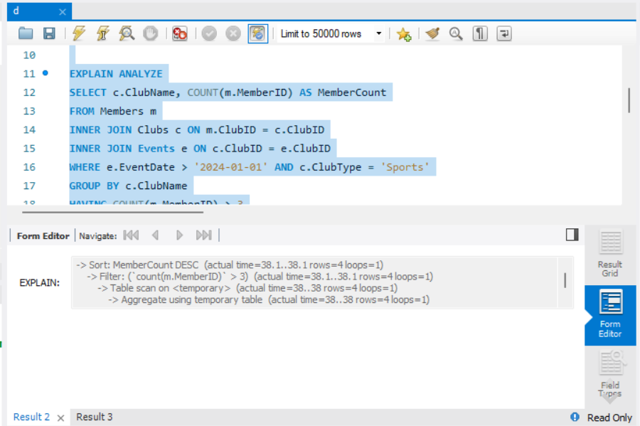

**As we can compare, the execution time after optimization has reduced from 129 sec to 38 sec**

**Join order variation 2 : Start with events**

**SELECT c.ClubName, COUNT(m.MemberID) AS MemberCount**

**FROM Events e**

**INNER JOIN Clubs c ON e.ClubID = c.ClubID**

**INNER JOIN Members m ON c.ClubID = m.ClubID**

**WHERE e.EventDate > '2024-01-01' AND c.ClubType = 'Sports'**

**GROUP BY c.ClubName**

**HAVING COUNT(m.MemberID) > 3**

**ORDER BY MemberCount DESC;**

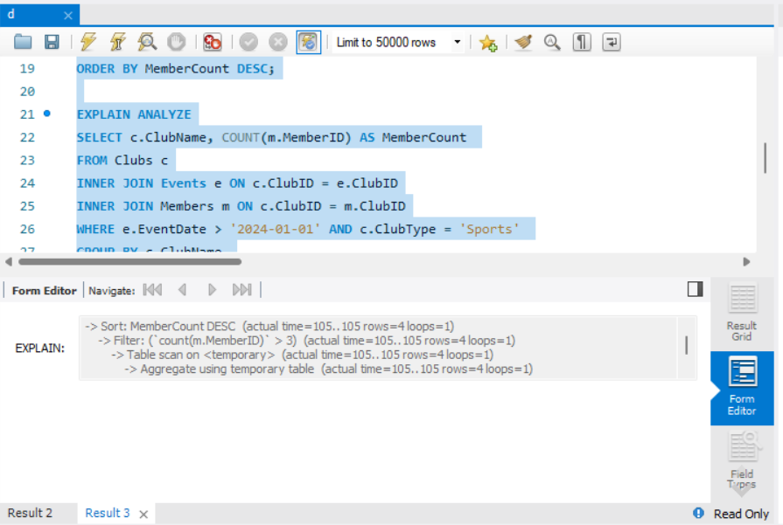

**As we can see the execution time has reduced from 129 sec to 105 sec**

**Incorporating a variety of join types such as outer joins, subqueries, etc., to diversify optimization approaches.**

**1)** **Using LEFT JOIN with Subquery Filtering**

**SELECT c.ClubName, COUNT(m.MemberID) AS MemberCount**

**FROM Clubs c**

**LEFT JOIN Members m ON c.ClubID = m.ClubID**

**WHERE c.ClubType = 'Sports'**

**AND c.ClubID IN (**

**SELECT DISTINCT e.ClubID**

**FROM Events e**

**WHERE e.EventDate > '2024-01-01'**

**)**

**GROUP BY c.ClubName**

**HAVING COUNT(m.MemberID) > 3**

**ORDER BY MemberCount DESC;**

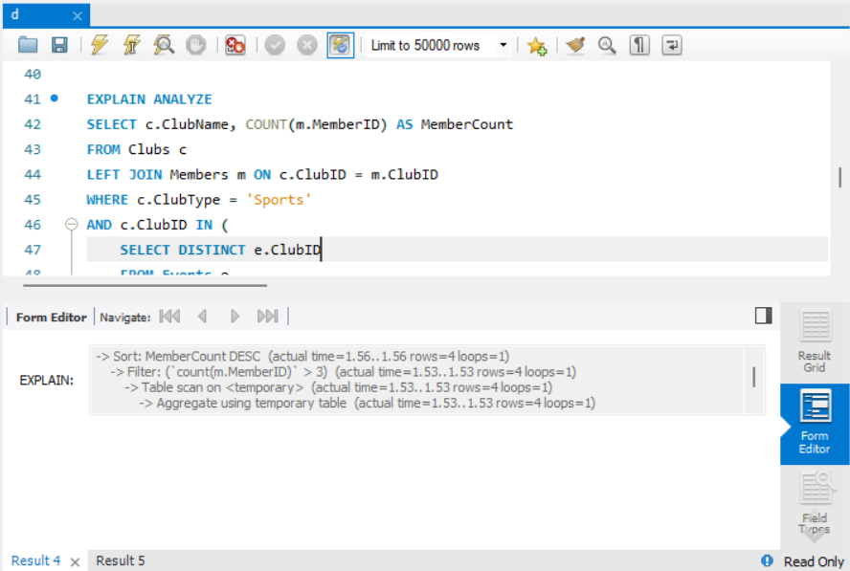

**As we can see the execution time has reduced from 129 sec to 1.56 sec**

1. **Using Common Table Expressions with INNER JOIN**

**WITH FilteredClubs AS (**

**SELECT ClubID, ClubName**

**FROM Clubs**

**WHERE ClubType = 'Sports'**

**),**

**ActiveClubs AS (**

**SELECT DISTINCT fc.ClubID, fc.ClubName**

**FROM FilteredClubs fc**

**INNER JOIN Events e ON fc.ClubID = e.ClubID**

**WHERE e.EventDate > '2024-01-01'**

**)**

**SELECT ac.ClubName, COUNT(m.MemberID) AS MemberCount**

**FROM ActiveClubs ac**

**INNER JOIN Members m ON ac.ClubID = m.ClubID**

**GROUP BY ac.ClubName**

**HAVING COUNT(m.MemberID) > 3**

**ORDER BY MemberCount DESC;**

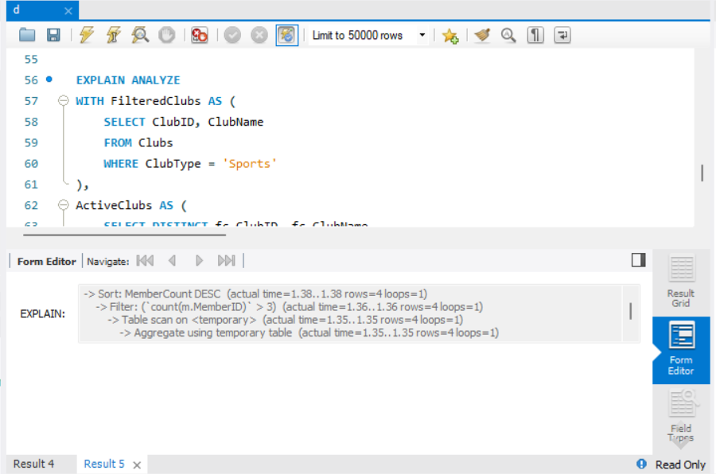

**As we can see the execution time has reduced from 129 to 1.38**

**e)**

**Part 1:**

**Parse tree:**

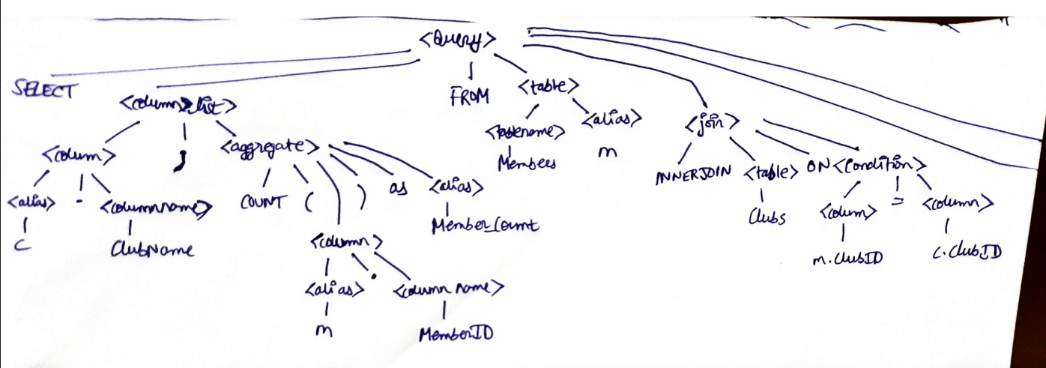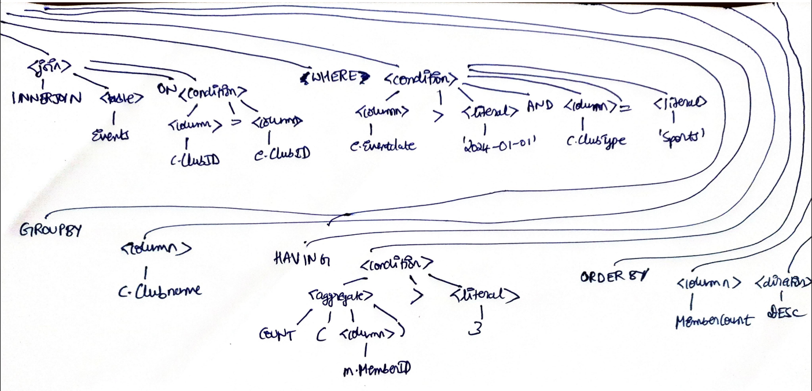

**The long lines drawn on the 2nd screenshot are all coming from <Query>. I didn’t have space to draw it on 1 single sheet which is why I combined 2 screenshots in this manner.**

**Relational Algebric Expression and Initial query tree**

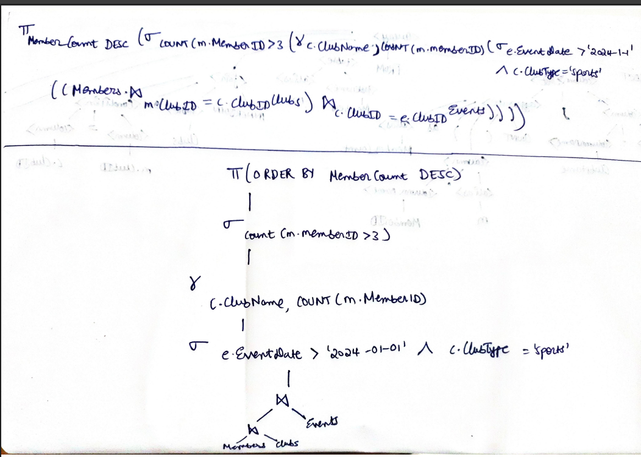

**Part 2:**

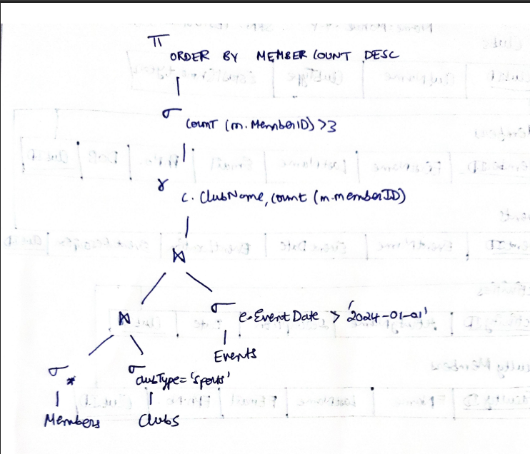

**Optimization : Pushing Selections Down**

* **In the initial query tree, the selection σ (e.EventDate > '2024-01-01' ∧ c.ClubType = 'sports') is applied after the joins.**
* **In the optimized query tree, these selection operations are pushed down and applied earlier on Events and Clubs before the joins.**
* **This reduces the number of tuples participating in the joins, making the query more efficient.**